SRS - Maithreyan's Connect Platform

The objective of this project is to develop a site to community engagement and alumni networking portal for Ananda Maithreya students across generations.

The system will provide a web-based platform with the ability to register and manage users, display content pages such as home, about, events and contact, allow users to join the community via a registration form, display event updates, provide admin controls.

**Product Functions**

- Landing page with mission, vision, CTA, events

- Join page with registration form

- Admin managed event announcements

- Contact page with static info

**User Classes and Characteristics**

-Visitors: Can view content but not interact.

-Registered Members: Can fill and submit forms.

-Administrators: Can add/edit events, view registrations, manage users.

**Design Mockups and System Features**

1. **User Registration (Join Page)**

- Users can register with their personal and contact details.

- Input Name, DOB, ID Number, Email, Gender, Address, Phone Numbers, WhatsApp, Optional Photo

- Output Registration confirmation

- Priority: High

* Acceptance Criteria:

- Form must validate required fields.

- Data is securely submitted and stored.

- Optional image uploads must be limited by size and format.

**Home Page Display**

- Show mission, vision, CTA, and events

- Priority: High

* Acceptance Criteria:

- Text content loads correctly.

- CTA redirects to /join.

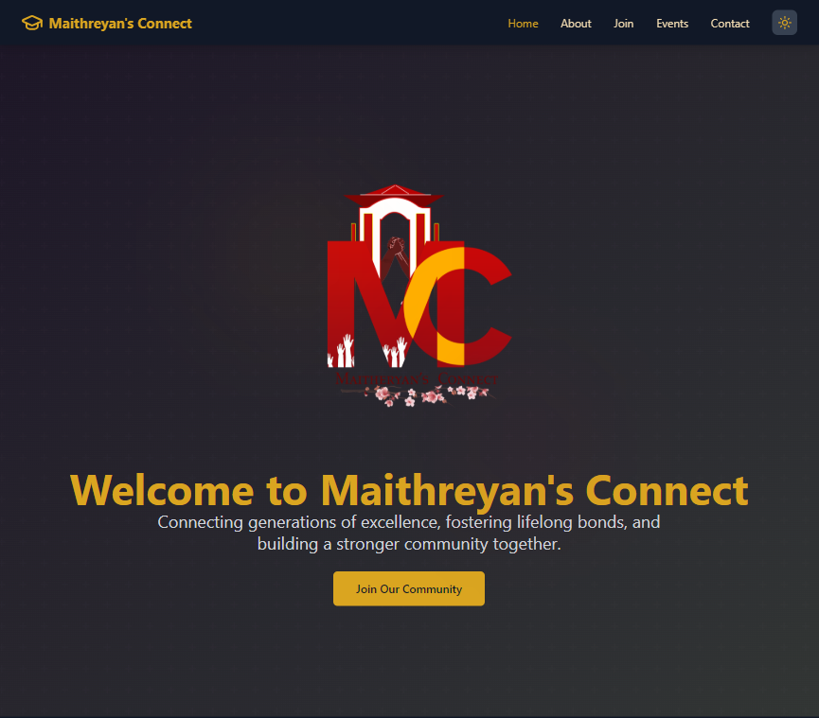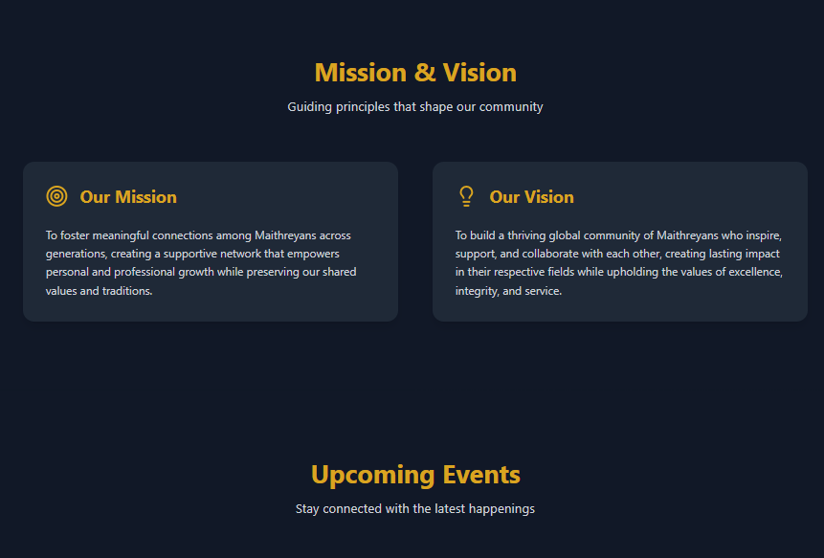- Events grid can dynamically update when populated by admin.

**Contact Page**

- Shows static contact info

Priority: Medium

* Acceptance Criteria:

- Info must match footer: email, phone, address.

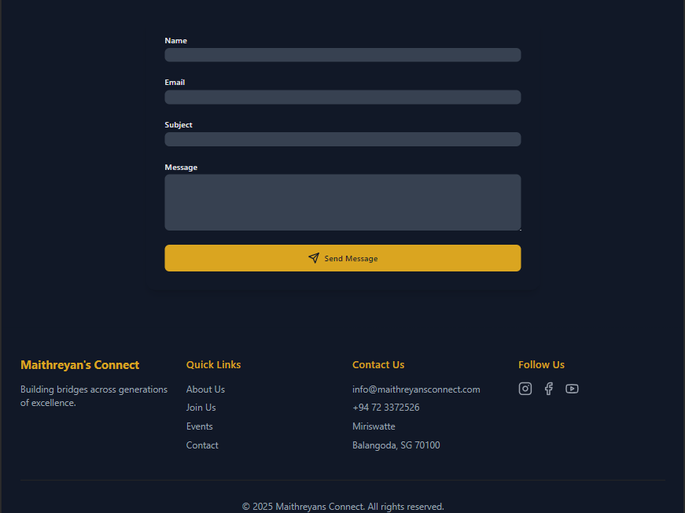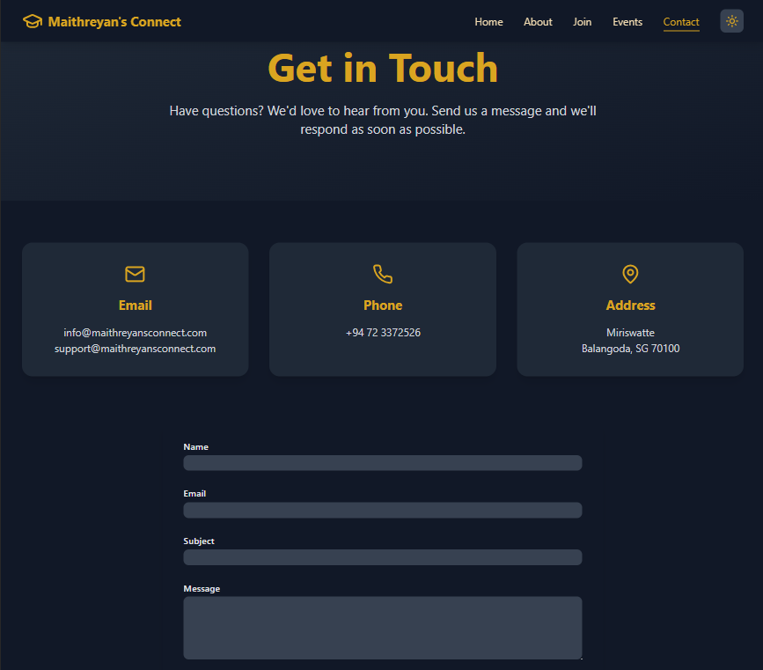- Include social media links.

**Event Management (Admin-only)**

- Admins can add/edit events.

Priority: High

* Acceptance Criteria:

- Events appear in the Home page 'Upcoming Events' section.

- Editable via admin panel (future iteration).

